EEZ project items
Opening a new or existing EEZ Studio project can be done by selecting options from the File menu in ESW or ESP module if it is already opened. Note that on the EEZ Studio start, the ESW module will be opened by default.

The EEZ Studio project items are organized into the following sections:
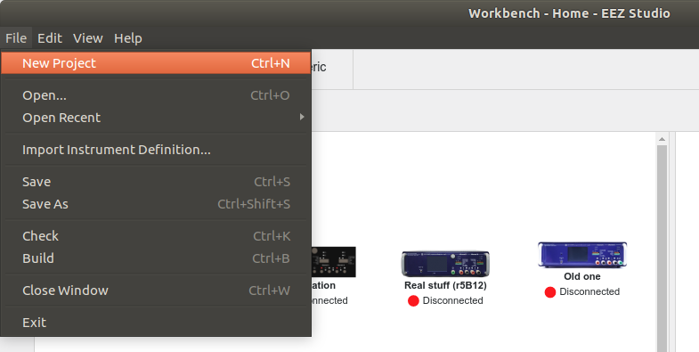Fig. 1: EEZ Studio New project option
- Settings
- Extension definitions
- Subsystems
- Shortcuts

